|  |
| --- |
| namco |
| Pac-Man |
| **1980s** |

Course: Intro to Game & Simulation (SEC. 001)

Professor: Balaniuc Wallace

Student ID:300962028

Student Name: Xiaoliang Wang

Table of Contents

Game Overview 4

Game Play Mechanics 4

Camera 5

Controls 6

Interface Sketch 7

Menu and Screen Descriptions 7

Levels 8

Characters 9

Non-player Characters and Enemies 9

Weapons 10

Abilities 10

Script 10

Scoring 11

Bonuses 12

Sound Index 12

Art Index 13

Design Notes 13

Future Features 14

Version History

Version1: Decide the thought of developing, building matrix map.

Version 2: Build the basic structure of this game

Version3: Add the basic logic of Pacman movement

Game Overview

*The main goal of Pac-Man is collecting all the Pac-Dots in the maze and avoiding ghosts attack. If any ghosts attack Pac-Man (touch him), Pac-Man will lose his life. When the player lost all Pac-Man lives, the game is over. But another item, flashing big Pac-Dots known as Power Pellets, can make the situation totally reversed. After eating that dot, there will be a period of time super power covering the Pac-Man. In this situation, the Pac-Man can eat the ghosts to get bonus score. So, If the player wants keep alive, controlling a good chance to eat flashing big Pac-dots is necessary strategy. And reaching certain level of scores can get extra Pac-Man lives.*

Game Play Mechanics

*In this game, the controller is quite simple, only Up, Left, Down, Right Arrow Key can be used to control Pac-Man to move in the maze. Eating normal Pac-Dots and flashing big Pac-Dots, occasionally some fruit showed near the ghosts’ home will increase players’ score. The most important is getting away from ghosts hitting. If the Pac-Man eats Power Pellets, all the ghosts will become flashing blue, moving slowly. In this situation, when they are eaten, their soul still alive as an moving eye mode and return to their home, a create box in the center of the maze. Then they will return dangerous again or after the impact of power pellets time. Finally, Pac-Man collected all the Pac-dots in this maze, the player can pass through this level.*

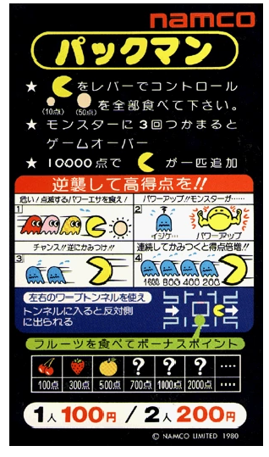

Camera

*This game is pure 2D game, and using the third person point of view. The player can directly distinguish which your character is in this maze.*

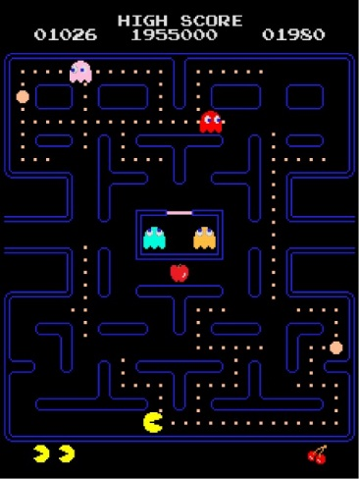

Controls

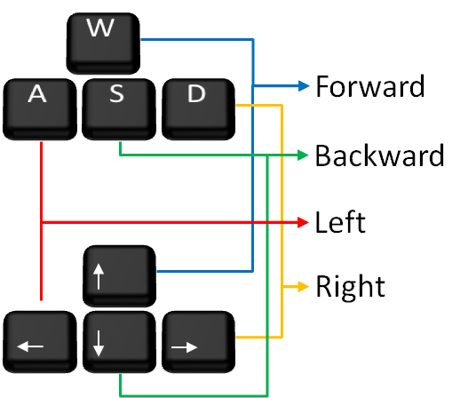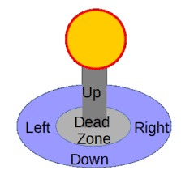

Interface Sketch

*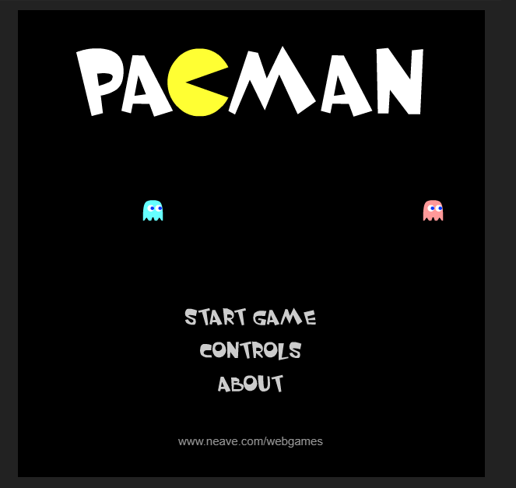***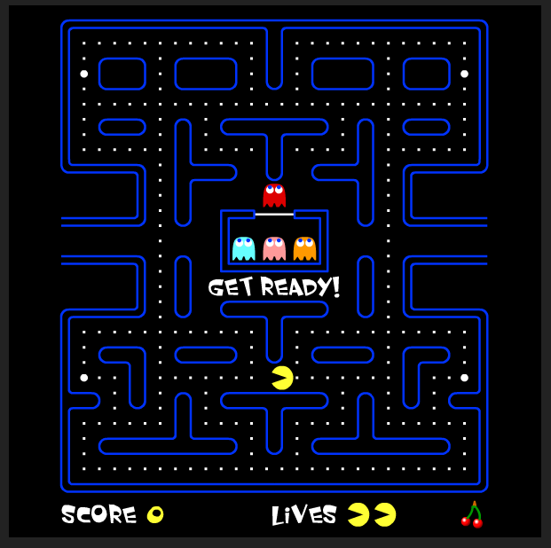**

Menu and Screen Descriptions

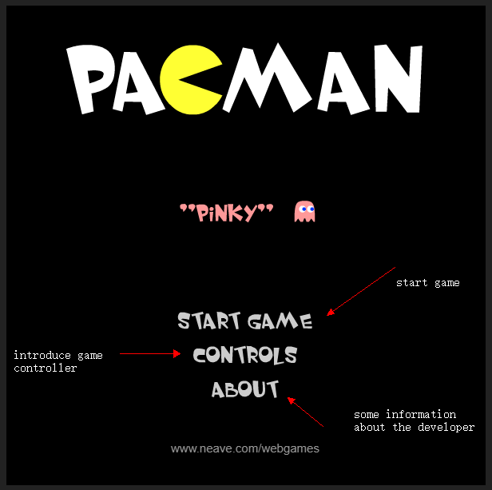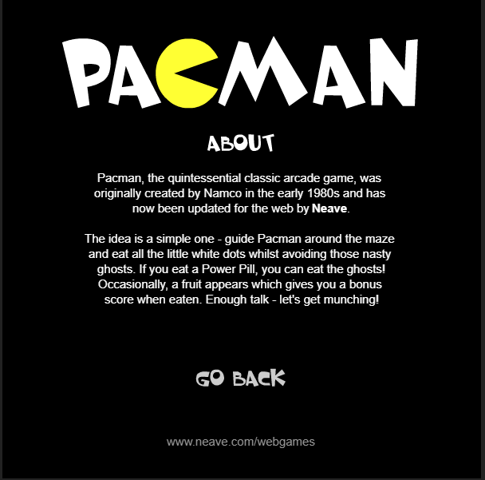

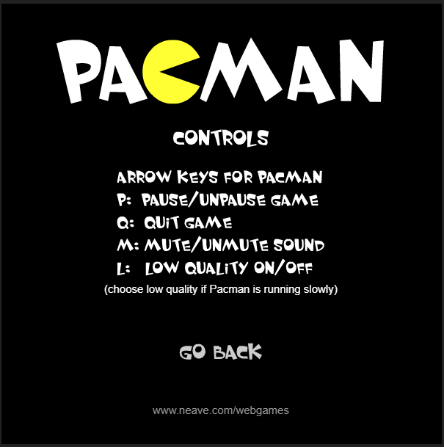

Levels

*Pac-Man is designed to have no ending game, which means that at least you have Pac-Man lives, the game will go on indefinitely. But there is a bug in the original design. The display area cannot show more than 7 fruits at the bottom of the screen. And as the original version is eight bits and stored a single byte, the number of your level can only reach 255 and next number will be zero.* *When the fruit number has overflowed to zero, the first decrement sets the fruit counter back to 255, causing the subroutine to draw a total of 256 fruit instead of the maximum of seven. It will show the “kill screen” like below.*

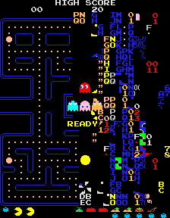

Characters

** *This is the only character-Pac-Man player can control.*

Non-player Characters and Enemies

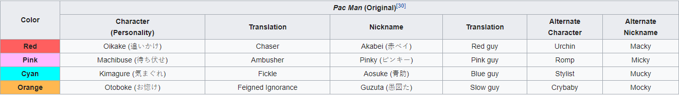

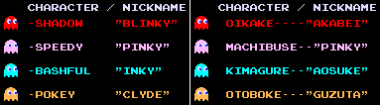

1. **Items**

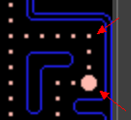

***Pac-Dots****: getting scores. And eating them all in this maze, player will pass this level.*

***Power Pellet:*** *Eating one causes the ghosts to become frightened and retreat for a short time.*

*http://pacmanmuseum.com/history/_picts/ICONS/cherry.gifhttp://pacmanmuseum.com/history/_picts/ICONS/strawberry.gifhttp://pacmanmuseum.com/history/_picts/ICONS/orange.gifhttp://pacmanmuseum.com/history/_picts/ICONS/apple.gifhttp://pacmanmuseum.com/history/_picts/ICONS/pineapple.gif* ***Fruits:*** *There is no extra benefits for players except getting scores.*

Weapons

*If weapon means player can against the enemies, the power pellets could be the only weapon in this game. The “weapons” called power pellets have four in each level, and located at the corner of the maze. (details in above picture, items)*

Abilities

*After eating the power pellets, the Pac-Man has the only ability that can eat ghosts in this game.*

Script

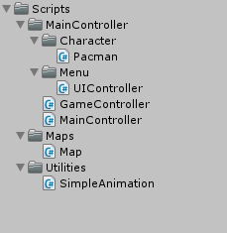

* Pacman Script: In this script, it mainly includes all the attributes of the Pacman object, like speed, current status, current direction and other details.
* UIController Script: Controlling all the functions in the main menu. Like start game, about button function and controller buttons.
* GameController Script: It includes all the logic in the gaming scene, which means all the gaming logical code in here. When you start the game, this script will be a commander, every input from player will pass here to deal with and then send to Pacman script, and monitor all the behaviors of every elements in the game.
* MainController Script: This is the core script. When unity runs, this script will run first, and to define current scene the player is in, and player’s status.
* Map Script: Because of using matrix as the basic of this game like original developers’ thought. So, I have to store a matrix map in this script.
* Simple Animation Script: To make every element animate like original one. So, want to use frame animation to implement this performance.

Scoring

|  |  |  |  |  |  |  |  |  |  |  |  |  |  |  |  |  |  |  |  |  |  |  |  |  |  |  |  |  |  |  |  |  |  |  |  |  |  |
| --- | --- | --- | --- | --- | --- | --- | --- | --- | --- | --- | --- | --- | --- | --- | --- | --- | --- | --- | --- | --- | --- | --- | --- | --- | --- | --- | --- | --- | --- | --- | --- | --- | --- | --- | --- | --- | --- |
| |  |  |  |  |  |  |  |  |  |  |  |  |  |  |  |  |  |  |  |  |  |  |  |  |  |  |  |  |  |  |  |  |  |  |  |  |  | | --- | --- | --- | --- | --- | --- | --- | --- | --- | --- | --- | --- | --- | --- | --- | --- | --- | --- | --- | --- | --- | --- | --- | --- | --- | --- | --- | --- | --- | --- | --- | --- | --- | --- | --- | --- | --- | | http://pacmanmuseum.com/history/_picts/ICONS/dot.gif***Pac-Dots****: are worth 10 points each*  http://pacmanmuseum.com/history/_picts/ICONS/energizer.gif ***Power pellets:*** *are worth 50 points each*   |  |  |  |  | | --- | --- | --- | --- | | *http://pacmanmuseum.com/history/_picts/ICONS/cherry.gif* | ***The cherry:*** *is worth 100 points. It appears during the first level of game play* | |  | | *http://pacmanmuseum.com/history/_picts/ICONS/strawberry.gif* | ***The strawberry****: is worth 300 points. It appears during the second level of game play* | |  | | *http://pacmanmuseum.com/history/_picts/ICONS/orange.gif* | ***The orange:*** *is worth 500 points. It appears during the third and fourth level of game play* | |  | | *http://pacmanmuseum.com/history/_picts/ICONS/apple.gif* | ***The apple:*** *is worth 700 points. It appears during the fifth and sixth level of game play* | |  | | *http://pacmanmuseum.com/history/_picts/ICONS/pineapple.gif* | ***The pineapple:*** *is worth 1,000 points. It appears during the seventh and eighth level of game play* | |  | | *http://pacmanmuseum.com/history/_picts/ICONS/spaceship.gif* | ***The Spaceship****: spaceship is worth 2,000 points. It appears during the ninth and tenth level of game play* | |  | | *http://pacmanmuseum.com/history/_picts/ICONS/bell.gif* | ***The bell****: is worth 3,000 points. It appears during the eleventh and twelfth level of game play* | |  | | *http://pacmanmuseum.com/history/_picts/ICONS/key.gif* | | ***The key****: is worth 5,000 points. It appears during the thirteen and all subsequent levels of game play* |  | | http://pacmanmuseum.com/history/_picts/ICONS/blue.gif | | ***Blue ghosts:***   * *The first ghost is worth 200 points* * *The second ghost is worth 400 points* * *The third ghost is worth 800 points* * *The fourth ghost is worth 1,600 points* * *If Pac-Man eats all four ghosts,  you earn a total of 3,000 points* |  | | | | | | |
|  |

Bonuses

## [Vulnerable Ghosts](http://pacman.wikia.com/wiki/Vulnerable_Ghost):

* #1 in succession - 200 points.
* #2 in succession - 400 points.
* #3 in succession - 800 points.
* #4 in succession - 1600 points.

Fruit**:**

* [Cherry](http://pacman.wikia.com/wiki/Cherry): 100 points.
* [Strawberry](http://pacman.wikia.com/wiki/Strawberry): 300 points
* [Orange](http://pacman.wikia.com/wiki/Orange): 500 points
* [Apple](http://pacman.wikia.com/wiki/Apple): 700 points
* [Melon](http://pacman.wikia.com/wiki/Melon): 1000 points
* [Spaceship Boss](http://pacman.wikia.com/wiki/Galboss): 2000 points
* [Bell](http://pacman.wikia.com/wiki/Bell): 3000 points
* [Key](http://pacman.wikia.com/wiki/Key): 5000 points

An extra life is awarded for 10,000 points.

Sound Index

* Pacman-beginning
* Pacman-chomp
* Pacman-eat ghost
* Pacman-extra Pac
* Pacman-death
* Pacman-intermission
* Pacman-death
* Pacman main background music

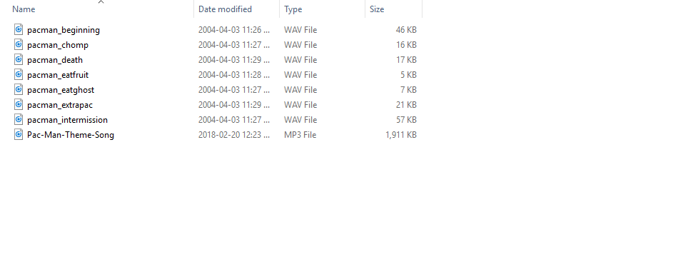

Art Index

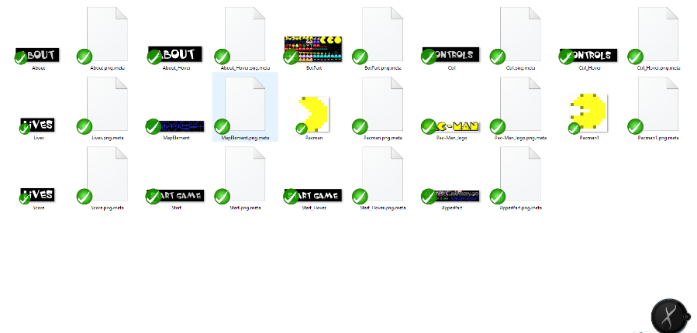

Design Notes

***1.****I want to design this game based on the original thought of its designer in eight bits machine game console. To implement this idea, I made a 32*28 matrix as the virtual map, then use many pieces of original art sprites to combine a real map.*

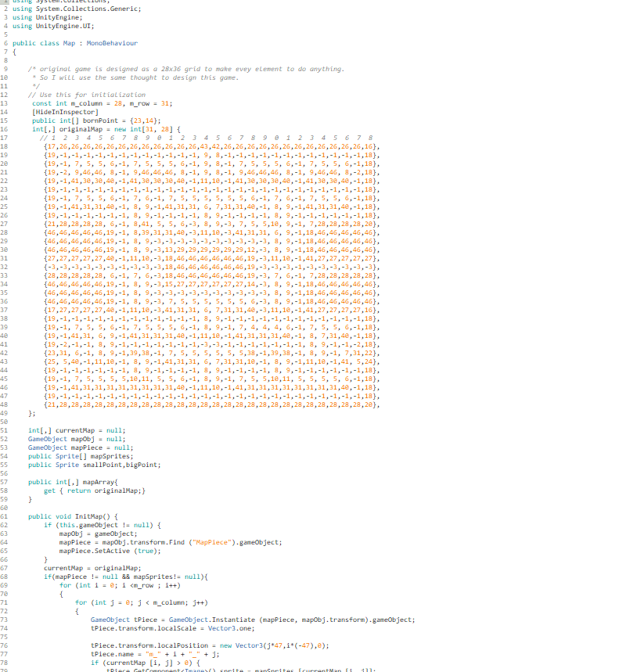

***2.****Controlling mechanism, based on the real mechanism of remote-controller. All the commands need to be sent by the game controller. MainController -> GameController -> Pacman. MainController -> UIController*

***3.***Some Utilities including SimpleAnimation, ScoreBoard, which can bind on the Animation sprite object and scores items.

Future Features

*1.AIController Script: mainly Control all the behaviours of ghosts.*

*2.The Gate: the Pac-Man pass through from left side to the right side of the maze.*

*3.Animation: even though I write the simple Animation script, but it’s not good enough to play some frame animations. Need to improve.*

*4.Score system: Count the scores player get from this game.*